A study on food brand (BURGER SINGH)

A
PROJECT-BASED LEARNING REPORT
Submitted to SAGE University, Bhopal
For the partial fulfillment of
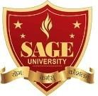
Bachelor of Business Administration SEM - 4 (2023-2024)

Submitted by Guided By
- Ananya Singh Mrs. Charul Chaturvedi 21BBA3ITM10005 ( ) (Assistant Professor)
- Aradhana Barve School of Management 21BBA3PLN10005 ( )
- Tanmay Dhakad Mrs. Saloni Sharma 22BBA3PLN40002 ( ) (Assistant Professor)
- Sujal Ahirwar School of Management
21BBA3BAF10024 ( )

School of Management, SAGE University, Bhopal Sahara Bypass Road, Katara Hills, Extension, Bhopal, Madhya Pradesh 462022

DECLARATION

Ananya Singh (21BBA3ITM10005), Aradhana Barve (21BBA3PLN10005), Tanmay Dhakad (22BBA3PLN40002), Sujal Ahirwar (21BBA3BAF10024), students of School of Management, SAGE University, Bhopal (M.P.) do hereby declare that Project Based Learning – IV entitled “A study on food brand (BURGER SINGH)” is an original work and has not been submitted anywhere in the quest of any degree.

Date: 1. Ananya Singh
(21BBA3ITM10005) ( )
Place 2.Aradhana Barve
(21BBA3PLN10005) ( )
  - Tanmay Dhakad (22BBA3PLN40002) ( )
  - Sujal Ahirwar (21BBA3BAF10024) ( )

CERTIFICATE

This is to certify that, Ananya Singh (21BBA3ITM10005), Aradhana Barve (21BBA3PLN10005) Tanmay Dhakad (22BBA3PLN40002), Sujal Ahirwar (21BBA3BAF10024), are the students of BBA Semester – IV. They have prepared Project Based Learning – IV under my guidance entitled “A study on food brand (BURGER SINGH)”.

( ) ( )
Mrs. Saloni Sharma Ms. Charul Chaturvedi
(Assistant Professor) (Assistant Professor)
school of Management School of Management
SAGE UNIVERSITY SAGE UNIVERSITY
BHOPAL BHOPAL

Date- Place-

ACKNOWLEDGEMENT

In completing this project, many people helped us. We would like to thank all those who are related to this project.
Primarily, we would thank God for being able to complete this project with success. We would like to express our special thanks of gratitude to our teacher Ms. Charul Chaturvedi who gave us the golden opportunity to do this project on the topic “A study on food brand (BURGER SINGH)” It helped us in doing a lot of Research and we came to know about a lot of things related to this topic. Her suggestions and directions have helped in the completion of this project.
Finally, we would like to thank our parents and friends who have helped us with their valuable suggestions and guidance and have been very helpful in various stages of project completion.

Date: 1. Ananya Singh
(21BBA3PLN10025) ( )
Place 2. Aradhana Barve
(21BBA3PLN10005) ( )
    - Tanmay Dhakad (22BBA3PLN40002) ( )
    - Sujal Ahirwar (21BBA3BAF10024) ( )

TABLE OF CONTENTS

Page No.
- Introduction [6-8]
  - About Burger Singh
- Review of Literature [9-10]
- Objectives 11]
- Research Methodology [12]
  - Research method
- Data analysis and interpretation [12]
  - Data source
    - Primary data
    - Secondary data
  - The tools
    - Tools for Collection of data
  - Limitations
- Questionnaire selection and validation [13-16]
- Questioner [17-19]
- Conclusion [20]
- Reference/ Bibliography [21]

Introduction

Burger Singh is a fast-food chain that has disrupted the Indian fast-food market with its unique menu offerings that fuse classic American fast-food with Indian flavors. Founded in 2014, the company has quickly grown to become a favorite among young Indian consumers, with over 35 outlets across India, as well as locations in the United Kingdom and the United States.

This case study analyzes how Burger Singh has been able to differentiate itself in a crowded market, leveraging innovative marketing and branding strategies, as well as menu innovation and a unique customer experience.

In addition to its unique menu and marketing strategies, Burger Singh has also been able to achieve impressive financial performance, with strong revenue growth and profitability. The company's lean cost structure, high volume sales, and efficient operations have all contributed to its success.

But despite its rapid growth and success, Burger Singh faces several challenges in the Indian market, including intense competition from established players, supply chain management issues, and regulatory hurdles. However, the company is well-positioned to continue to innovate and adapt to the changing tastes and preferences of Indian consumers.

"Burger Singh is not just a fast-food chain, it's a symbol of the fast-food revolution in India," says Singh. "We're proud to be a part of that revolution, and we're excited to see where it takes us next.

About

Burger Singh is Gurgaon based fast food chain which operates under the company name tipping Mr. Pink Pvt ltd.
Burger Singh was founded in November 2014 by three childhood friends Kabir jeet Singh, Rahul Seth, and Nitin Rana

Kabir Jeet Singh – Founder Nitish Rana – Cofounder

Burger Singh has followed a unique market strategy that has helped it stand out from other fast-food chains in the Indian market. Here are some of the key elements of the company's market strategy:
- Unique Menu
- Social Media Marketing
- Customer Engagement
- Lean Cost Structure

Burger Singh has followed a unique market strategy that has helped it stand out from other fast-food chains in the Indian market. Here are some of the key elements of the company's market strategy:

Unique menu offerings: Burger Singh has differentiated itself from other fast-food chains in India by offering a fusion of classic American fast food with local flavors and ingredients. The company's menu includes items like the "Butter Chicken Burger" and the "Aachari Paneer Burger," which have become popular favorites among Indian consumers.

Social media marketing: Burger Singh has leveraged social media platforms like Facebook, Instagram, and Twitter to create a sense of community and connection with its customers. The company has used humorous advertising and social media influencers to engage with its target audience and build brand awareness.

Customer engagement initiatives: Burger Singh has focused on creating a fun and engaging customer experience, with bright colors, quirky signage, and interactive elements like the "Wall of Singh" where customers can take selfies with the company's logo. The company has also introduced loyalty programs, promotions, and discounts to encourage repeat business.

Lean cost structure: Burger Singh has focused on keeping costs low by adopting a lean operating model. The company has minimized overhead costs by operating in small, low-cost locations and leveraging technology to optimize its supply chain and inventory management.

Overall, Burger Singh's market strategy has been successful in creating a unique brand identity and generating buzz among its target audience. The company's focus on customer engagement, social media marketing, and unique menu offerings has helped it stand out in a crowded market and build a loyal customer base.

Review of Literature

- University-SRM Institute of Science and Technology Academic year: 2020/2021
Uploaded by-SANJAY MEHROTRA

>marketing plan of Burger Singh includes all the related aspects of the company, which are used by the organization in approaching a maximum customer base increasing its market share.

In addition to market penetration, the company should focus on product innovation also.

The above includes all the required aspects of marketing plan of Burger Singh, such as marketing strategies, target market, objectives etc. SWOT analysis of company.

company faces countless internal and external issues in environmental analysis, which will influence their business operations which is prominent in the industry analysis.

>Burger Singh identifies its company strengths, weaknesses, opportunities, and threats in three stakeholders’ group.

Besides, in applying the swot analysis is essential that help company to minimize and avoid weaknesses and threats. The weaknesses in company must be scrutinized to changed them into strengths part. Similarity, in the other way around the threats should be changed into opportunities. Therefore, both strengths and opportunities will be matched to optimize company potential for accomplishes goals in the fast-food industry. Though it has a long way to go Burger Singh has created a market for itself and is here to stay.

- Upload: THURSDAY 21 JUL 2022 AUTHOR - Ajinkya Salvi

The fresh capital will be used to expand the franchise with additional 120 food outlets, accelerate brand growth and hiring.

Fast food chain Burger Singh has announced the fundraising of ₹30 crore in series A funding round led by Negen Capital. Existing investors like RB Investments, Rukam Capital, KCT Family Office, and VM Salgaocar family office also participated along with Old World Hospitality (Rohit Khattar) and Jasleen Royal (Singer, songwriter, and composer with over 80 stores in more than 38 cities, the company is the fastest- growing burger chain of Indian origin. It also has the country's 3rd highest burger delivery volumes.

- Updated: 05 Oct 2015, 01:19 PM IST AUTHOR - Priyanka Sahay

Gurgaon-based Tipping Mr. Pink Pvt. Ltd, which runs quick service restaurant (QSR) chain and online ordering site Burger Singh, has raised
$500,000 in fresh funds from a group of investors.

>The investors include Avtar Monga, chief operating officer, IDFC Bank; Dheeraj Jain, partner at Redcliffe Capital, a UK-based hedge fund; angel investor Ashvin Chadha; and early-stage investor Udaan Angels.

>The firm, which has four outlets in Gurgaon, will utilize this money by expanding in Delhi with six outlets in the next six months. It also plans to enhance its website to drive more orders through it.

>According to Singh, the company also plans to raise another $3 million and will be initiating conversations with institutional investors in a few months.

>As the name suggests, Burger Singh offers an Indianized version of burgers. Its product line comprises over 13 types of burgers, besides beverages, desserts, and fries. The price of the burgers is in the range of ₹ 80-220.

>The company has over 40 employees across operations and execution, including six in the senior team. It plans to hire around four to six more people for senior positions.

>The fast-food market is expected to reach a turnover of ₹ 7,000 crores by 2015- 16, growing at an average annual rate of about 27%, according to data from research and rating agency Crisil Ltd.

- Objective

- To know how BURGER SINGH gained its reach.
- Knowing about consumer reaction to the new food chain.
- To know about the marketing mix and pricing.
- Knowledge about the advertising strategy.
- Knowledge about the competition.

- Researcher Methodology

4.1 RESEARCH METHOD:
The strategies, processes, or techniques utilized in collecting data or evidence for analysis to uncover new information or create a better understanding of a topic.

- DATA COLLECTION METHOD: We have used the survey method with the help of Google Forms for data collection. The survey is the most commonly used method and gives you some approximate results as well.
The questionnaire contains some questions like:
The age group, gender, what’s your preferences, frequent use of customers, prefer the same drinks or not, etc.
  - DATA SOURCE:
- Primary Data: The current research was conducted in Bhopal city from December 2022 to January 2023 using questionnaires shared with the consumer. We have received 44 responses which are slightly according to our expectations which was 50 - 60.
- Secondary Data: we have collected secondary data from some literature that have already been published in the form of research paper, articles, and reports. Material available on different websites is also considered.

  - THE TOOLS
    - Tools for collection of data: We used google forms for a survey and prepared a questionnaire for the collection of data from the crowd.

  - Limitation
    - Limited access to data.
    - Lack of previous research study
    - The data we grabbed from the previous research paper was not updated as per the research scenario.
    - Sample size depends on the nature of the research problem.

- Questionnaire selection and validation
The current research was conducted in Bhopal City from February 2023 to May 2023 using questionnaires shared with the consumers. We have received 44 responses which is slightly according to our expectations.
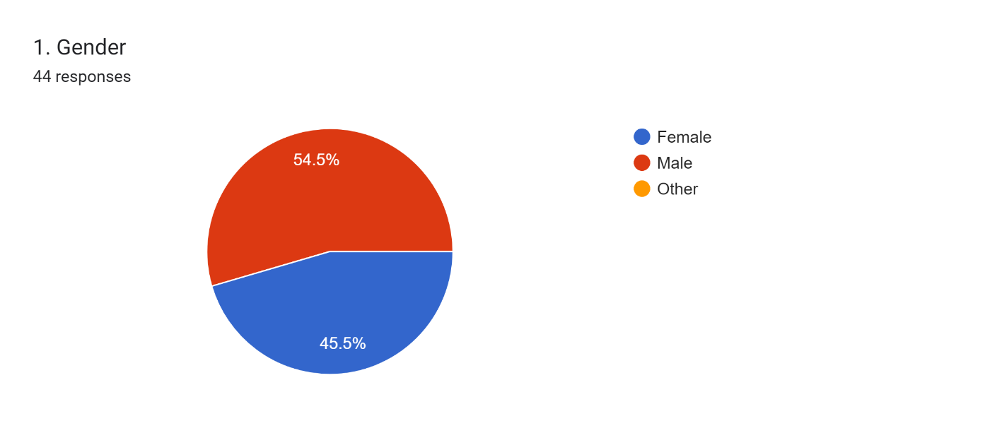

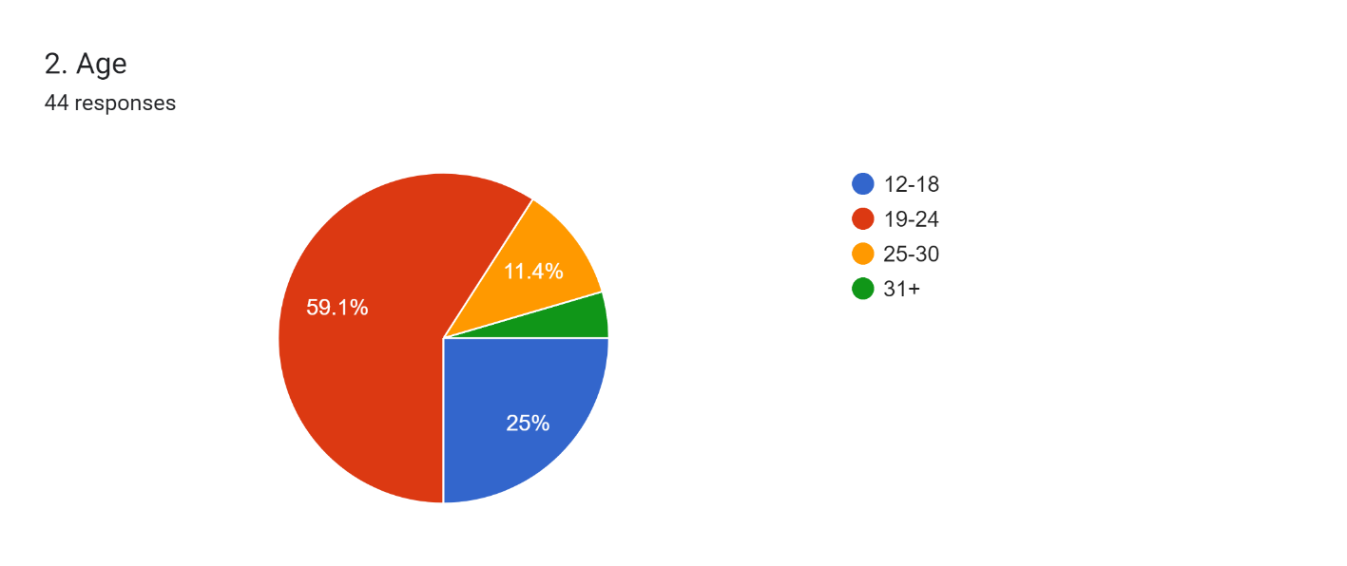
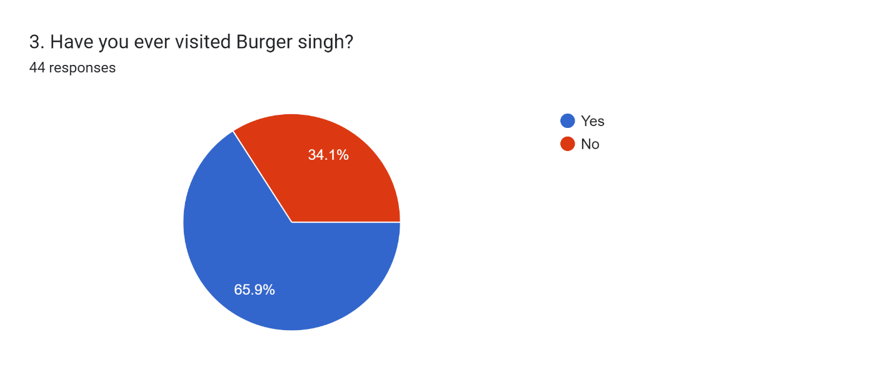

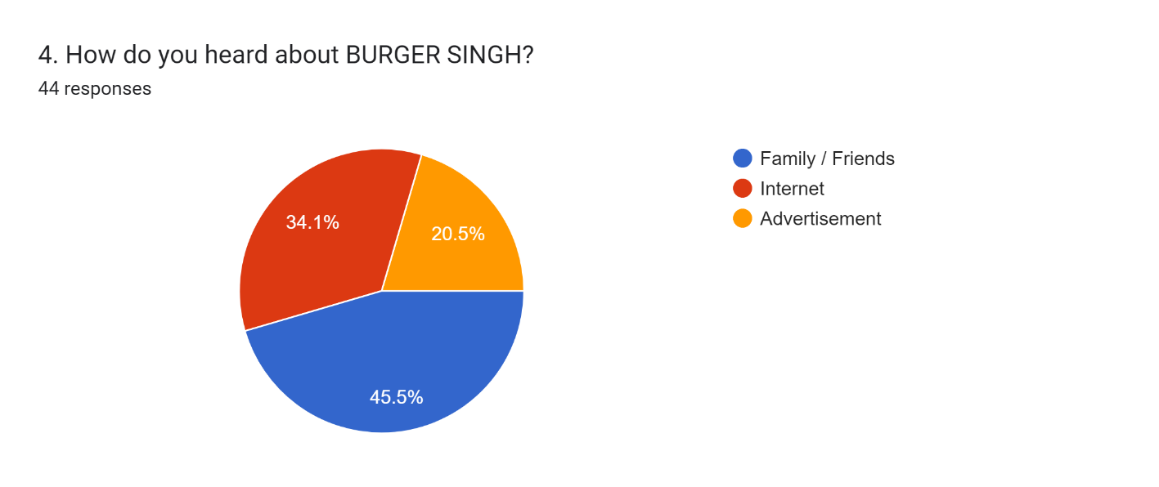

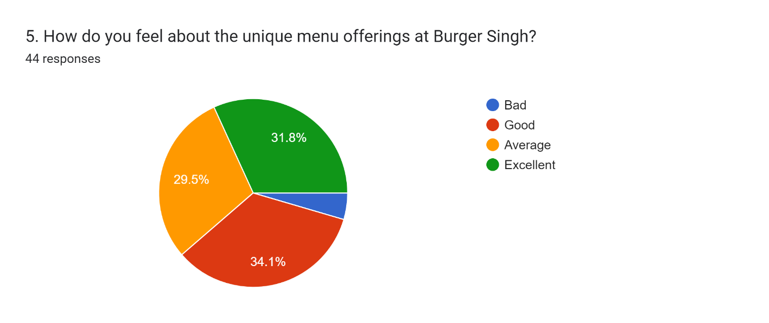

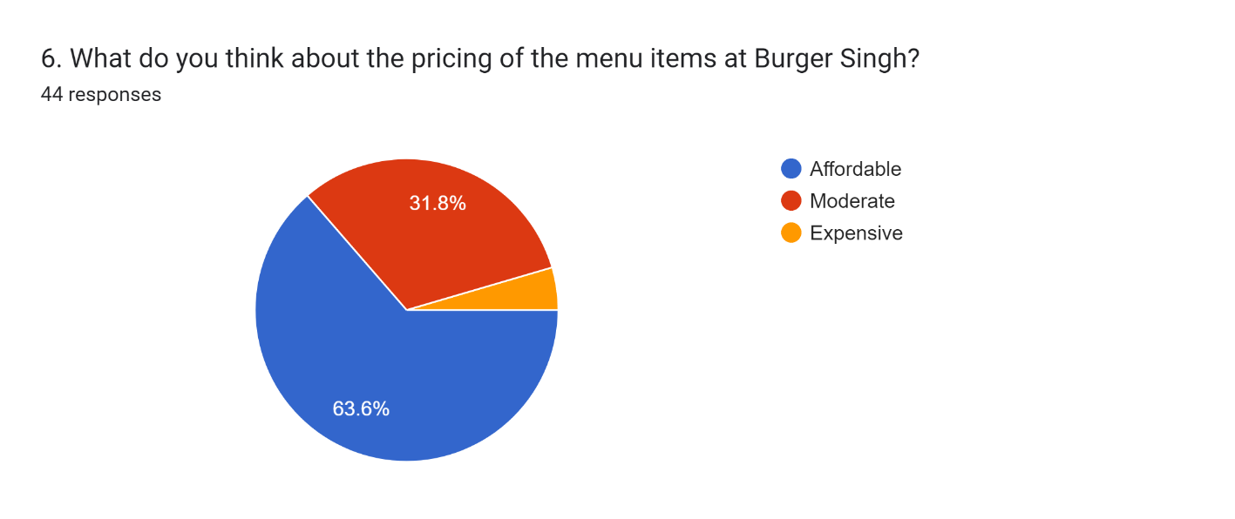

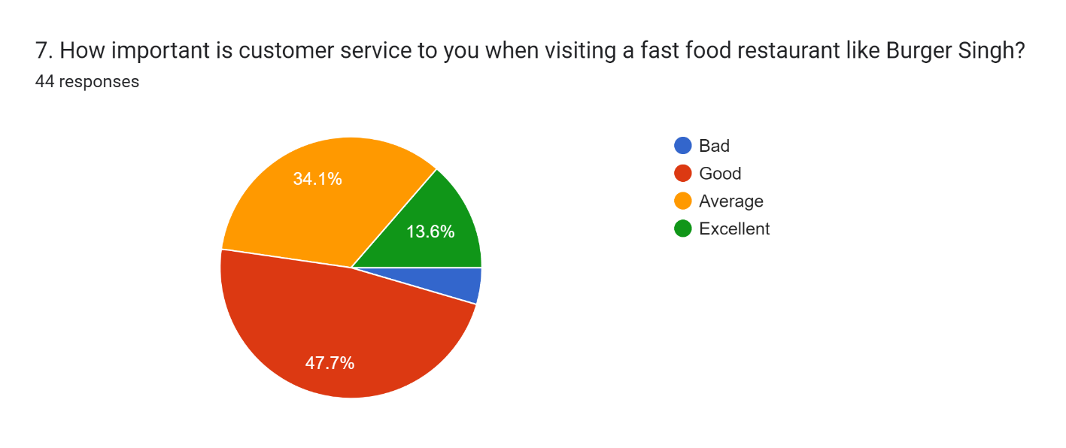

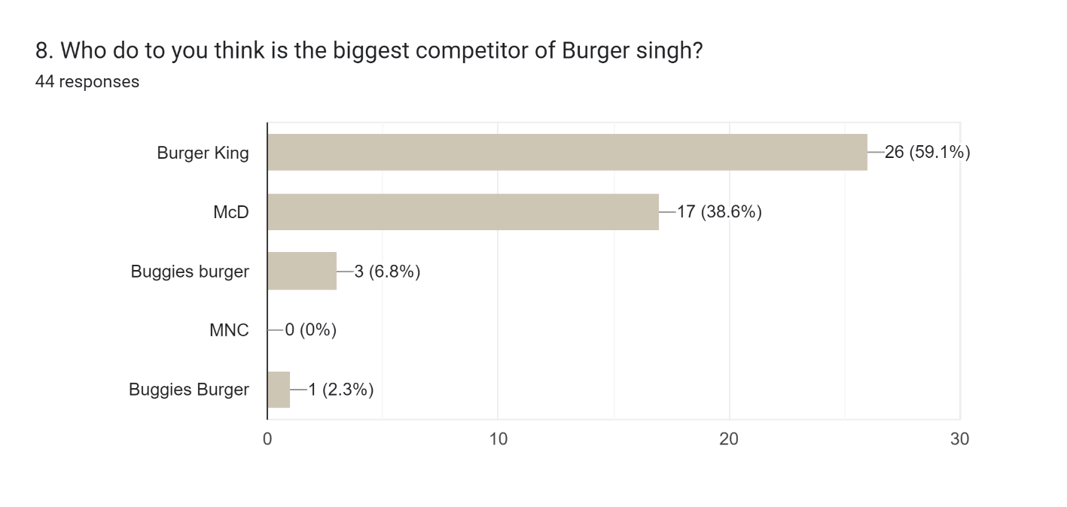

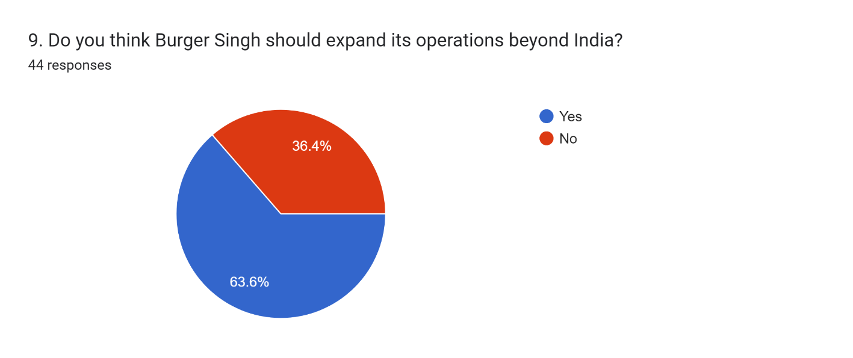

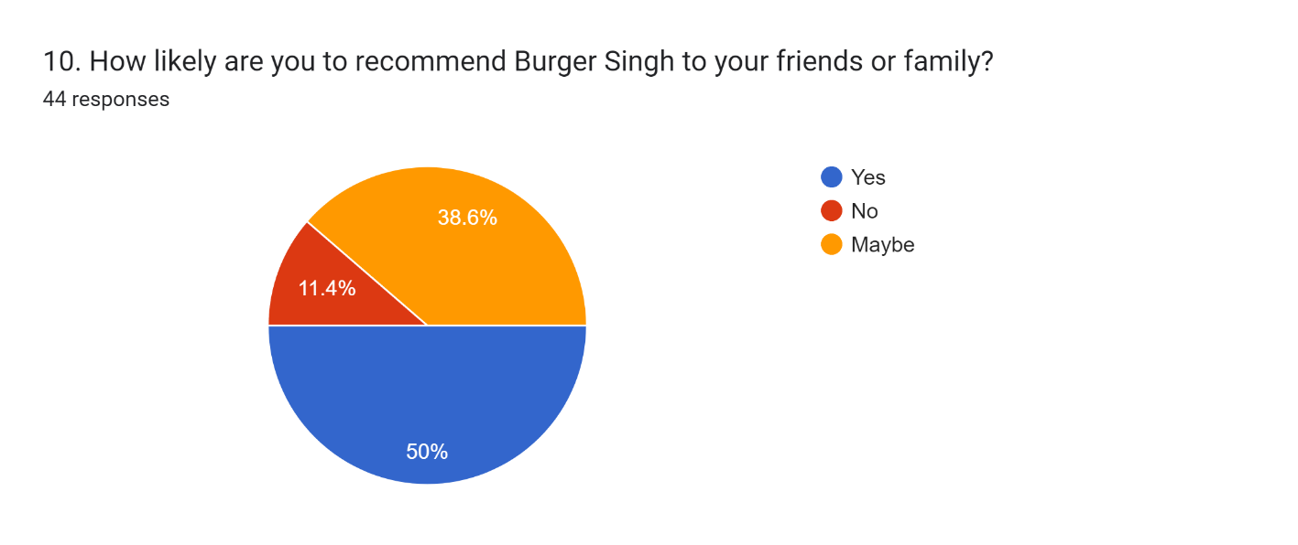

Questioner

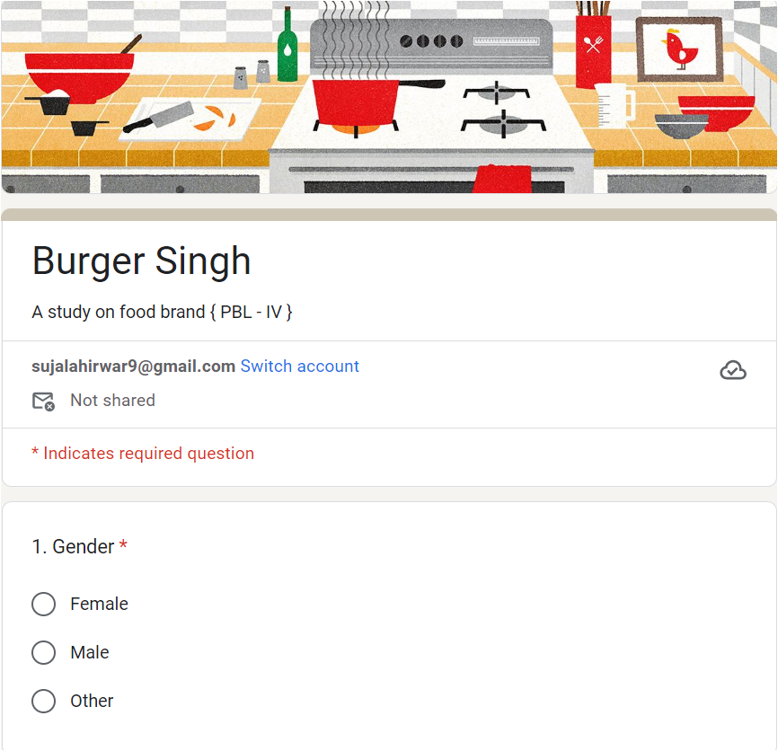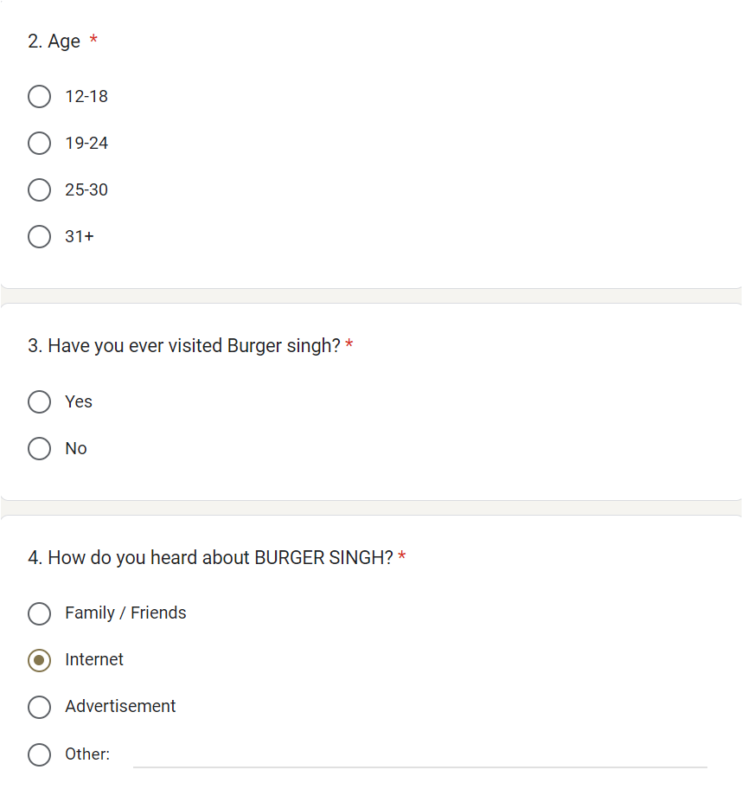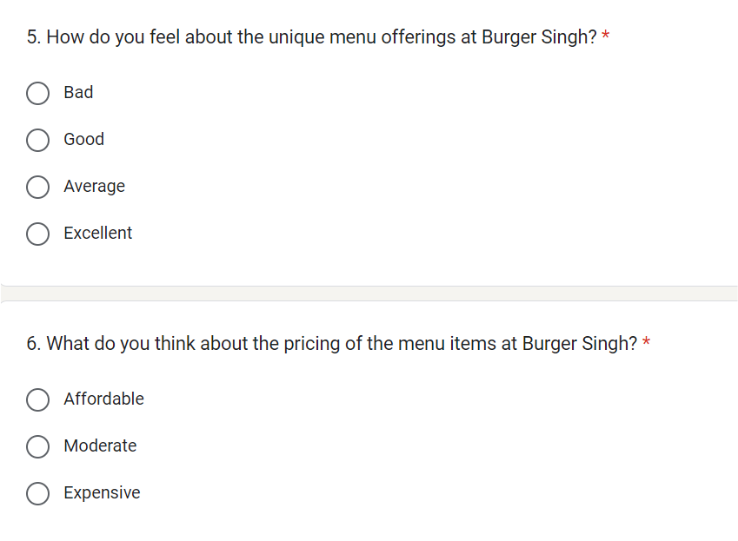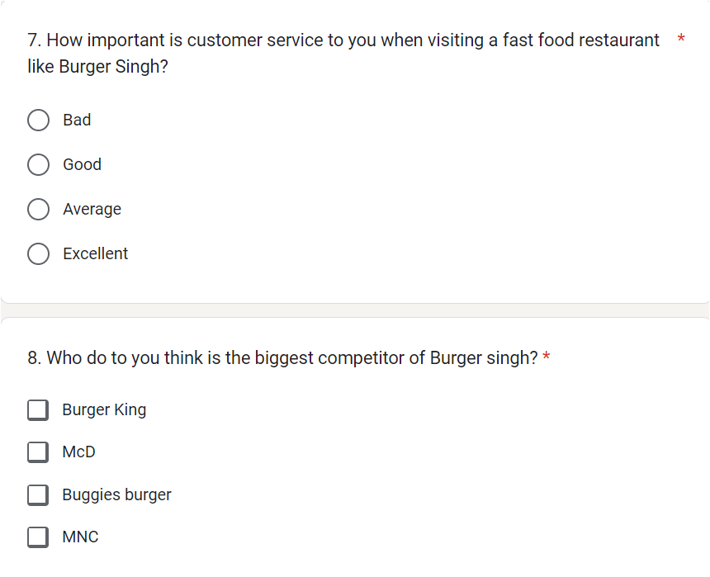

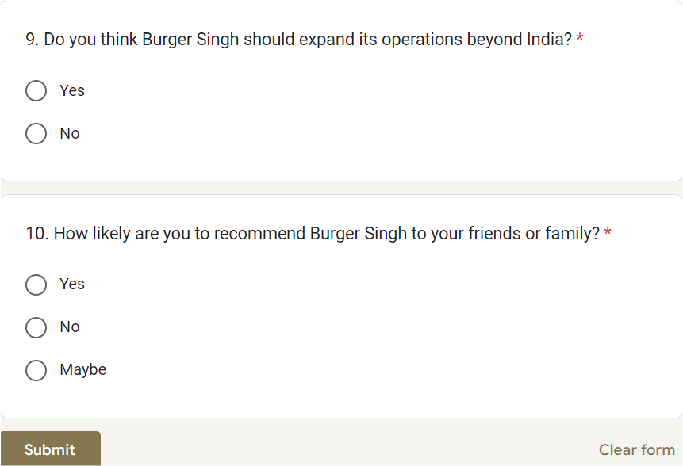

Conclusion
Through our survey on BURGER SINGH, the researchers have found out that most of the consumers are adults who are aged between 19 - 24, Burger Singh has gained its reach by spreading its awareness to people through family and friends. Tho they try to provide unique items in their menu but some people find it average/regular. The main thing which attracts people is their price, it's very affordable for most of the people. Burger Singh had gained its reach by having the support of pvt. Pink Limited, by reviewing some literature we got to about consumers’ reactions towards the Indian taste in the burger. We understood the marketing technique and the strategy taken by BS to take down their competitors from the market like MC Donald, burger king. Overall, Burger Singh's market strategy has been successful in creating a unique brand identity and generating buzz among its target audience. The company's focus on customer engagement, social media marketing, and unique menu offerings has helped it stand out in a crowded market and build a loyal customer base.

- Reference/ Bibliograpy
- https://scholar.google.com/scholar?hl=en&as_sdt=0%2C5&q=research+paper+on+burger+singh&btnG=
- https://scholar.google.com/scholar?hl=en&as_sdt=0%2C5&q=article+on+burger+singh&btnG=
- https://www.livemint.com/Companies/BfQ6EJSPuALLPDJfWb2OBL/Burger-Singh-restaurant-raises-500000-in-fresh-funds.html
- https://www.peoplematters.in/news/funding-investment/fast-food-chain-burger-singh-secures-30-crore-in-negen-capital-led-series-a-funding-34643
- https://www.studocu.com/in/document/srm-institute-of-science-and-technology/master-of-business-administration/burger-singh-marketing-strategy/8189106
- https://bwhotelier.businessworld.in/article/Burger-Singh-records-400-per-cent-surge-in-revenue-within-12-months/14-12-2021-414768/
- https://www.google.com/search?q=artciles+on+burger+singh&rlz=1C1CHBF_enIN1015IN1015&oq=artciles+on+burger+singh&aqs=chrome..69i57j33i10i160l2.22136j0j7&sourceid=chrome&ie=UTF-8
- https://restaurant-guru.in/Burger-Singh-Bhopal
- https://www.retail4growth.com/news/qsr-brand-burger-singh-steps-up-expansion-plans-to-open-16-outlets-in-bihar-6134
- https://magicpin.in/Bhopal/Arera-Colony/Restaurant/Burger-Singh/store/a48603/
- https://www.google.com/search?q=artciles+on+burger+singh+in+bhopal+madhya+pradesh&rlz=1C1CHBF_enIN1015IN1015&sxsrf=APwXEdfS9mVoWgY5ykDU6ydFH4l7lj63Qw%3A1680935331350&ei=owkxZP6CFbiwseMPhPK8yAc&oq=artciles+on+burger+singh+in+bhopal&gs_lcp=Cgxnd3Mtd2l6LXNlcnAQAxgAMgcIIRCgARAKMggIIRAWEB4QHTIICCEQFhAeEB06CggjELACELADECc6BAghEBVKBAhBGAFQqQFYiRlgmi1oAXAAeACAAYECiAH3EJIBBTAuMi44mAEAoAEByAEBwAEB&sclient=gws-wiz-serp
- https://www.studocu.com/in/document/srm-institute-of-science-and-technology/master-of-business-administration/burger-singh-marketing-strategy/8189106
- https://leverageedu.com/blog/kabir-jeet-singh/
- https://www.peoplematters.in/news/funding-investment/fast-food-chain-burger-singh-secures-30-crore-in-negen-capital-led-series-a-funding-34643
- https://www.google.com/search?q=when+did+burger+singh+gained+its+profit&rlz=1C1CHBF_enIN1015IN1015&oq=when+did+burger+singh+gained+i&aqs=chrome.2.69i57j33i160l2.13263j0j7&sourceid=chrome&ie=UTF-8
- https://www.facebook.com/BurgerSinghIndia/

